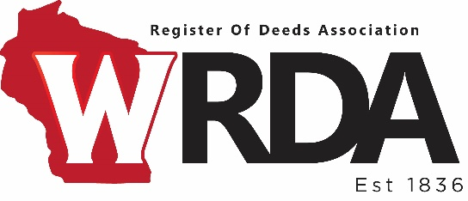

PRIA Scholarship/Reimbursement Application

ARTICLE X SECTION 5 of WRDA bylaws read: PRIA Conference Attendance. The WRDA board may allocate up to $2,000 annually for one or more Registers to attend a PRIA conference. PRIA attendees will provide a written report to the association about the conference. Applications must be submitted to the WRDA board in accordance with the application guidelines developed by the WRDA board.

Date submitted to Board: Click or tap to enter a date.

Name of Applicant:

County: Phone:

Address:

City: State: WI Zip Code:

Date of PRIA Conference you plan to attend: Click or tap to enter a date.

Location of Conference:

Have you received the PRIA scholarship in the past?  Yes **OR**  No

If yes, please give date: Click or tap to enter a date.

Include any details you would like the board to consider:

Date of Board meeting: Click or tap to enter a date.  
Board Decision:  Approve **OR**   Decline

If declined reason:  
  
____________________________________________________________________________________  
  
____________________________________________________________________________________  
  
  
WRDA President’s Signature: _________________________________________

**PRIA Scholarship Application Process**   
  
a. Members should submit their completed PRIA Scholarship/Reimbursement Application to the WRDA President during the month of April, the year prior to the PRIA Conference being applied for. Applications submitted after April 30th may not be considered.  
  
b. The WRDA Board will vote on the number of scholarships to be awarded at the Summer Board meeting (typically held in May) based on the current financial health of the WRDA. The Board will also vote on who the recipients will be at this meeting.  
  
c. Applications will be considered based on the following: 1) received prior to submission date, 2) whether recipients received a prior PRIA scholarship, and 3) any and all other criteria will be considered. One alternate (per # of awards) will be chosen in case an awardee must back out.  
  
d. Recipient(s) of award(s) will be announced at the WRDA Summer Conference (typically held in June). This should allow recipients enough time to complete their County budgets accordingly.  
  
e. Scholarship funds shall be disbursed after the PRIA conference and after a written report has been submitted to the WRDA President with an invoice of expenses totaling the amount of the scholarship.  
  
SAMPLE Timeline: April 2022 applications submitted; May 2022 Board meeting to decided # of recipients and who recipients are; June 2022 Recipients announced at Summer Conference; February/August 2023 PRIA Conference held.